

Colegio Tecnológico Pulmahue

CUARTO MEDIO
Name:
El objetivo de esta guía es que los estudiantes comprendan la importancia de la seguridad vial e identifiquen información relacionada en textos.

Para dudas que tengan pueden escribirme un correo a esta dirección: yorka.sepulveda.pulmahue@gmail.com, escribiendo en el asunto el nombre de él o la estudiante y su curso, el horario para correos es de 9am a 7pm. Cualquier consulta sobre los contenidos y asignatura será respondida y también en caso de que necesiten material extra.

O.A: comprender importancia de la seguridad vial como conductores y peatones al momento de cruzar las calles.
O.A2: Identificar información en textos.

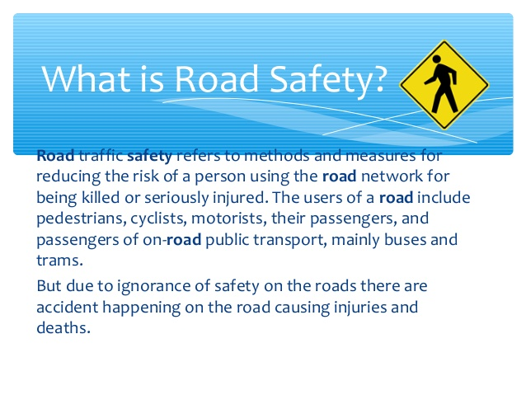

Search for other definitions of road safety, write here, use a dictionary definition or your own words.
ROAD SAFETY:

There is an event in many countries that is called road safety week, in this event many subjects related to road safety are taught and learnt.

Now we will read about the road safety week of last year, you have to identify information related to road safety and the reading in general.


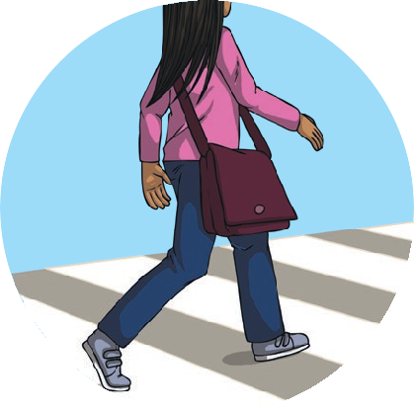

Road Safety Week 2019
Road Safety Week is an event to raise awareness of how to stay safe when out on the roads. It happens every year and this year, Road Safety Week is happening on 18th – 24th November. Each year there is a different theme. The theme this year is ‘Step up for Safe Streets’.

What Does ‘Step up for Safe Streets’ Mean?
This year, Road Safety Week wants people to learn about and celebrate how we get around safely every day. This can mean everything from how a road is designed and the speed limits decided, to the use of safety technology in vehicles.
Every year, more people are cycling or walking to work or
school as it is good for their health and a good form of exercise. It is also better for the environment. However, every 20 minutes, someone is killed or seriously injured on British roads in accidents that could often be avoided. Not only do we need to be aware about how to stay safe on roads but our local councils can step up and provide ways for people to walk or cycle safely too.

There are many things you can do to make sure that you stay safe on the roads.
First, always make sure you are aware of others on the road; look both ways as well as listening carefully before crossing the street.
Make sure you use crossings to cross the road when you can, such as zebra crossings and pelican crossings.
Finally, if you notice somewhere where it is tricky to cross safely, write to your local council and ask them to make a change and step up for safe streets.
Staying Safe
Follow the Green Cross Code to stay safe when crossing.
- Find a safe place to cross.
- Stop in front of the kerb.
- Look both ways and listen
for traffic.
- Let traffic pass.
- When it is safe, walk straight across the road. Do not run.
Ways to Cross
There are five different types of crossings in the UK, they are:
- Zebra
- Puffin
- Pelican
- Toucan
- Pegasus

INVESTIGATE AND ANSWER (Writing task)

- What are the ways to cross the streets in Chile? Name them

- Which are the main traffic rules in Chile that drivers and pedestrians should respect to avoid accidents?

- Do you think people in Chile use or respect these rules?

ANSWER THESE QUESTIONS ACCORDING TO THE READING

